SUMMER INTERSHIP PROGRAMME
OF UPSLSA-2016

The Hon’ble Chief Justice, High court of Judicature at Allahabad who is also the Patron-in-Chief of the Uttar Pradesh State Legal Services Authority (hereinafter UPSLSA) observed in the 25th Annual General Meeting that students of Law Universities should be associated in the work of legal literacy. These law students in addition are expected to act as para-legals for monitoring the Legal Awareness Programmes.

The UPSLSA ever since its inception has arranged for different avenues of creating a sensitized knowledgeable man power to bring legal empowerment. Young law students of Universities if are given the right orientation about their prominent role to act as medium of facilitating legal services to the marginalized people in need, they may prove to be a catalyst in bringing about the intended change leading to legal empowerment. The UPSLSA during the course of the internship programme, by providing all relevant information about the structure and objectives of the legal service institutions to the interns, not only tries to make the students aware about the activities of the institutions but also has expectations from the interns that they would be inspired to make some contribution in our efforts.

UPSLSA, with this objective in mind, started the training of law students in January, 2009 in summer and winter seasons. Law students pursuing 5/3 yrs LLB courses are presumably well-versed with the basic tenets of legal provision. They are required to be equipped to voluntarily act as a bridge between the common man and legal services institutions so that they may act as remover of barriers to ‘Access to Justice’.

The barriers to Access to Justice in the Indian socio-cultural milieu has been historically recognized in large number of studies carried out by the Law Commission of India, expert groups constituted from time to time and in the judgments of the Hon’ble Supreme Court of India. In the report of the Expert Committee on Legal Aid under the chairmanship of Hon’ble Mr. Justice Krishna Iyer- “Processual Justice to the People”- a large number of barriers to ‘access to justice’ have been enumerated. Illiteracy, social backwardness, physical, geographical, social and psychological distancing and even mental incapacity act as real barriers to the common people for getting access to the seats of justice. The result is that they become silent sufferers even while they face abject denial of justice.

In fulfillment of this objective, the UPSLSA under the patronage of Hon’ble Mr. Justice V.K. Shukla, Acting Chief Justice, Allahabad High Court and Executive Chairman, UPSLSA conducted the XII Summer Internship Programme for Law students in the month of June, 2016. Under the directions of Hon’ble the Executive Chairman, the UPSLSA took the decision of including most of the students, who applied for participation in the programme. Accordingly the internship programme progressing from the participation of 22 students in the first internship programme of January, 2009 saw the participation of more than 100 students in its latest batch.
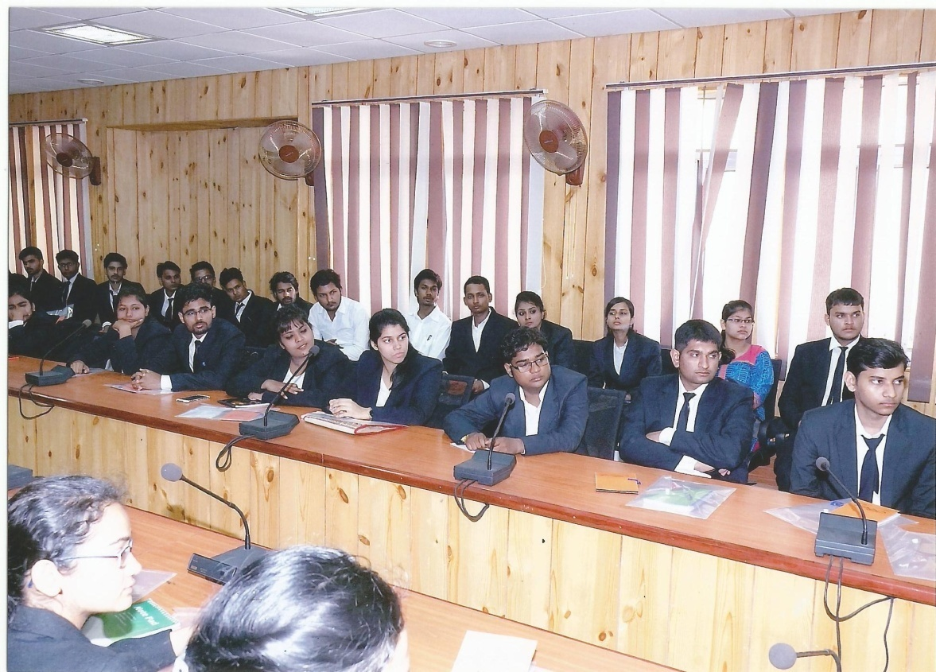
The UPSLSA, which conducts the internship programme without charging any fee from the interns, has designed the programme in a way that the students are exposed to the practical realities of the application of the justice dispensation system. The practical exposure of the interns is interspersed with interactive discussions on different aspects of the justice delivery mechanism with focus on the activities of the legal services institutions dedicated to providing free legal aid and assistance to the disadvantaged persons of the society and for making different Alternative Dispute Resolution Mechanisms as the suitable and effective mode of dispute settlement.

The internship programme was inaugurated on 1st June, 2016 by Hon’ble Mr. Justice D.K. Upadhyaya, Judge, High Court, Lucknow Bench, Lucknow. Justice Upadhyaya inaugurating the programme shared his experience as a Judge as well as a lawyer and stressed on the need to focus on providing quality, inexpensive and timely justice to the litigants. Justice Upadhyay during the course of his talk made a beautiful distinction between the concept of profession and business. Illustrating on the meaning of the word profession, His Lordship said that this inter alia involves the element of service, whereas, business above everything has the component of profit as the essential ingredient. In this light, he concluded by observing that advocacy is a profession and accordingly the interns, whenever, adopt the profession should never forget to always remember the aspect of service in the performance of their profession.
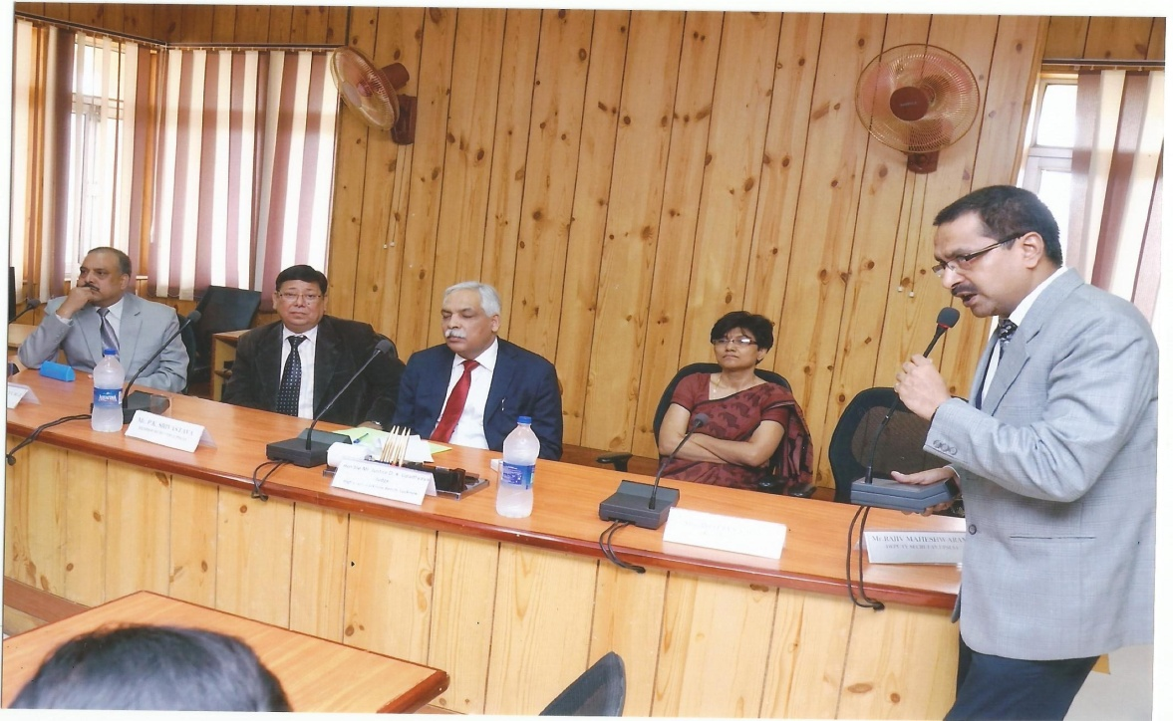

During the course of the internship programme, talk was also delivered by Hon’ble Mr. Justice Rajan Roy, Judge, High Court, Lucknow Bench, Lucknow on the topic “Challenges Before the Justice Delivery System”. His Lordship outlining the various challenges like huge arrears & pendency, increasing cost of litigation, poor and tardy investigation, low judge - population ratio etc. appealed the law interns to prepare themselves in a better way to face those future challenges and to take up carrier as judges and judicial officers, in addition to taking up litigation with the added objective of helping the poor and disadvantaged sections of the society. The students were also motivated by Mrs. Bulbul Godiyal – the first women advocate to be designated as Senior Advocate, who delivered an interactive talk on ‘ADR Mechanisms’. The judicial officers on deputation at the UPSLSA, including the Member Secretary also delivered talks on different topics pertaining to Structure of the Legal Services Authorities; JJ Act; Criminal Justice Administration; Family Court Structure etc. The various schemes being implemented by the UPSLSA as per NALSA directions, as also, the focused areas and other activities were shared with the interns.

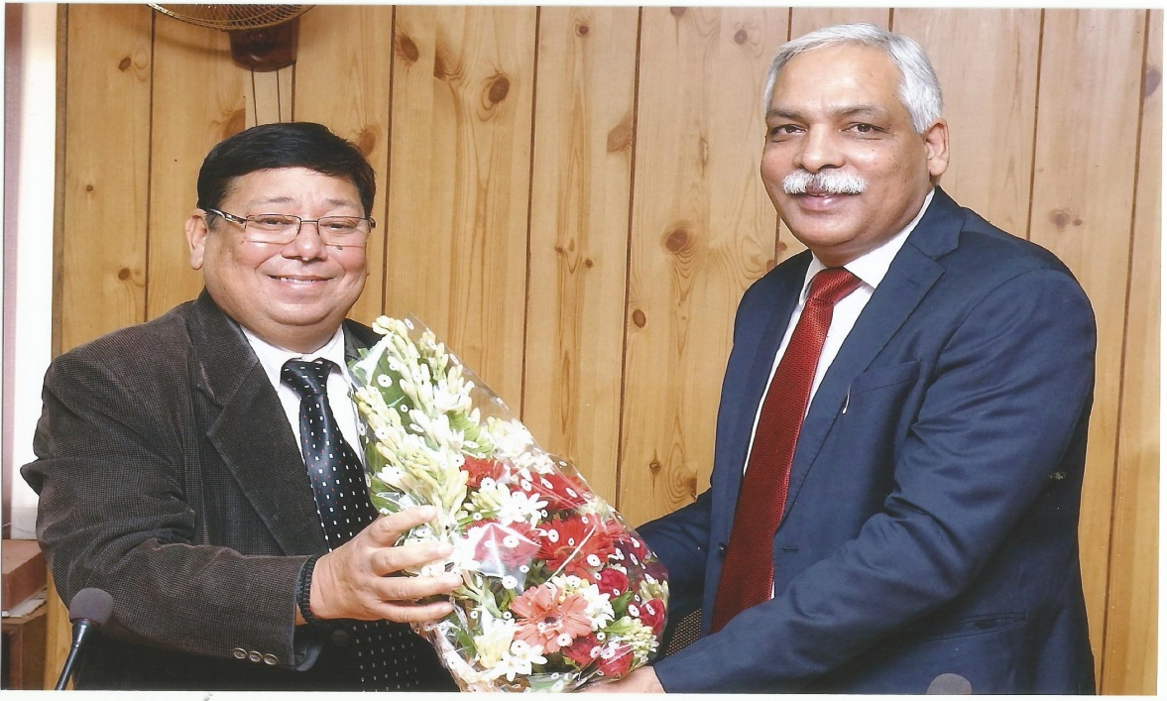

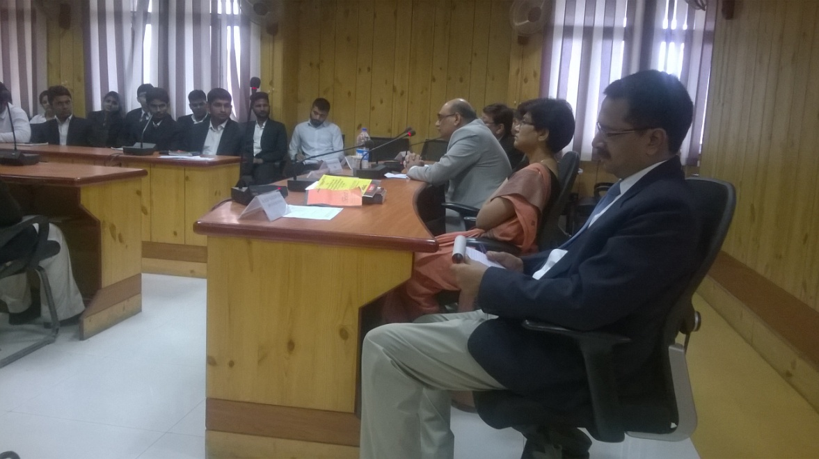

As part of the endeavour to provide the first hand experience of the legal process in action, the interns were taken on visit to the Hon’ble High Court, Lucknow Bench, Lucknow; District Court, Lucknow; District Jail; Children Home; Observation Home; Police Station; Cyber Cell; 1090 Women Power Line; Forensic Science Laboratory; ‘Drishti’ – A home for mentally challenged and other destitute children etc. It is hoped that coming of face to face with certain realities would instill a greater sense of responsibility amongst the participating interns and as a result of which, they would prove to be
harbingers of fair weather as ambassadors of the legal services institutions.

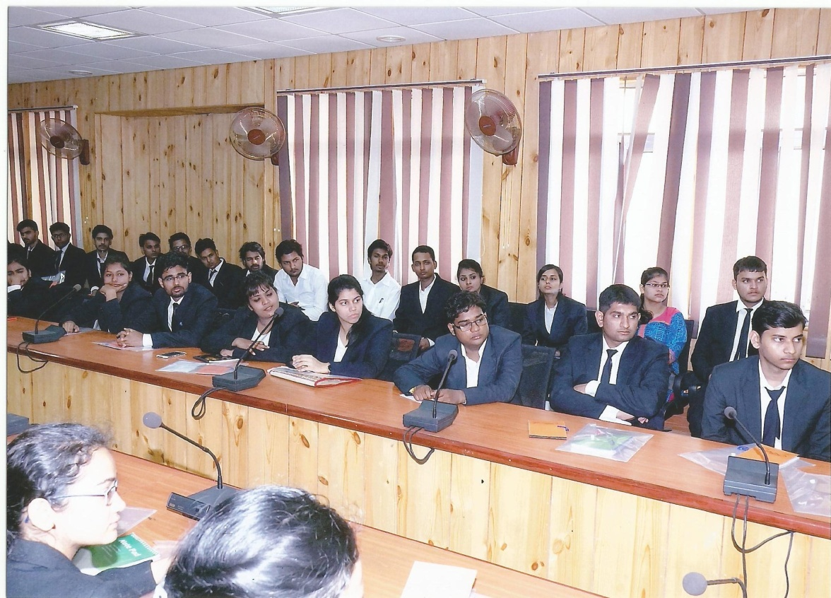

The students were also required to submit a project report on the topics, as were allocated by UPSLSA on the opening day of the programme. Keeping in mind, the 07 schemes launched by NALSA and 05 focused areas adopted by the UPSLSA, the topics were selected by amalgamating those identified areas and the overall work sphere of the authority.

Accordingly, the following topics were selected on which, each intern was required to select any one topic and submit a detailed write up for being submitted to the UPSLSA:
- The need of providing legal aid and assistance to the workers in the unorganized sector.
- The need of providing legal aid and assistance to the mentally ill and mentally disabled persons.
- The need of providing legal aid and assistance to the victims of drug abuse and eradication of drug menace.
- The role of legal services institutions in achieving the objectives of the PC and PNDT Act, 1994.
- The role of legal services institutions in protecting the rights of under trial prisoners.
- Mediation and Conciliation with minor difference in approach have similar objectives.

The UPSLSA hopes that the law students who have participated in the internship programme shall further the cause of providing preventive and curative solution to the disadvantaged people in their quest for justice. The approach, structure and efforts of the UPSLSA has been unanimously appreciated by the participating law interns.

